**Lab manual 6!**

**Selection statements (switch-case)**

**Learning Objectives:**

The objective of this exercise is to make you familiar with the selection statement

**switch case**. **Introduction:**

A ‘switch’ statement allows a variable to be tested for equality against a list of values. Each value is called a case, and the variable being switched on is checked for each case.

**Example 1:**

Write a C++ program to input number from user and check whether the number is even or odd using switch case.

**Code:**

#include <iostream> using namespace std;

/* function main begins program execution */ int main( void )

{

int num, rem;

cout<<"Enter a integer, and I will tell you wether the number is even or odd:\n"; cin>>num;

rem=num%2;

switch(rem)

{

case 0:

cout<<"Even"; break;

case 1:

cout<<"Odd"; break;

default:

cout<<"Something went wrong"; break;

}

return 0; /* indicate that program ended successfully */

}

**Task 1:**

Write a C++ program to create menu driven calculator that performs basic arithmetic operations (add, subtract, multiply and divide) using switch case.

**Input :**

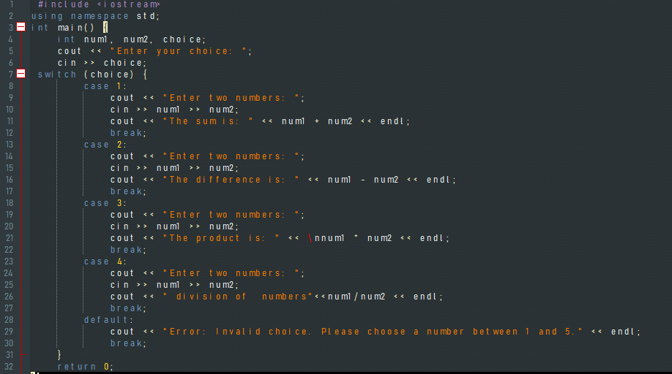

**Output :**

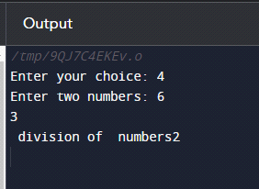

**Task 2:**

Write a C++ program that uses switch-case to count the number of each different letter grade students earned on an exam.

**Input :**

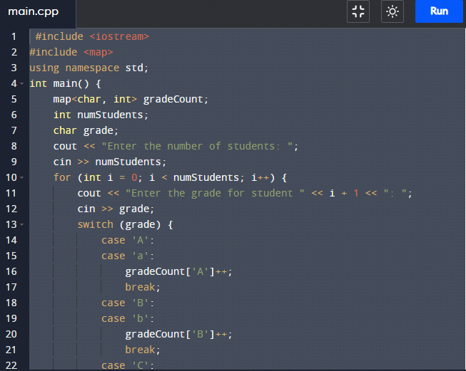

**Output :**

